- What is the total number of attributes in the customer table?

Customer table has 3 columns: CustomerID, Customer Age, Customer Gender.

- How will you get the “Customer’s” ages in the “Order” tables according to customer IDs?
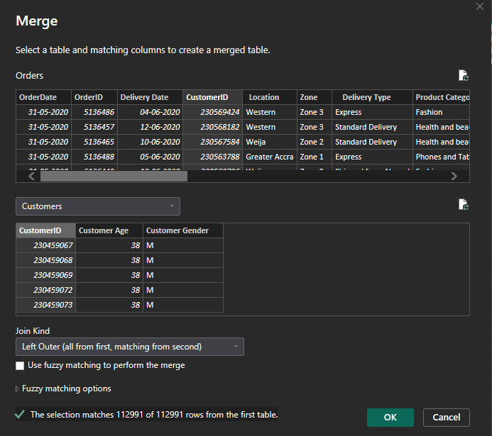
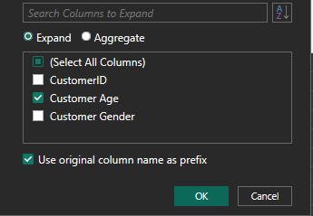
- Merged Orders and Customers on customerID and kept only Customer Age when expanding the customers table in orders table.

- In analyzing the dataset with Power BI, ensure data cleaning to address inconsistencies and missing values before further analysis.

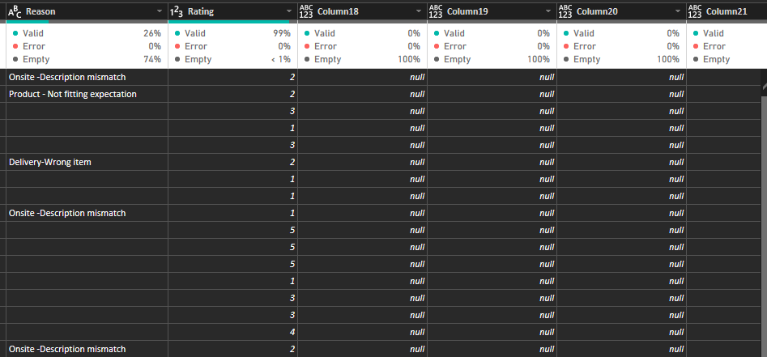

- Removed ‘null’ or empty cells from all the columns
- In Reasons column in Orders table , replaced empty cells with “Not Returned”
- Gave appropriate data types to all the columns
- Identified that all the locations belong to the country “ghana” so added a Country Columns and data characterized it to “Country”
- Data categorized “Location” column to “State/province”
- Merged the customer table to get “Costomer age” in orders table.
- Made a “Calender _table” and connected it to the remaining tables so as to use better time-intelligence functions
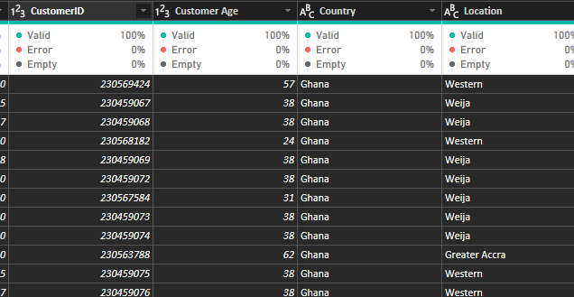
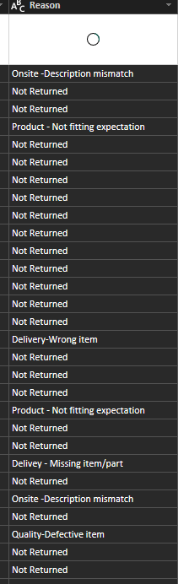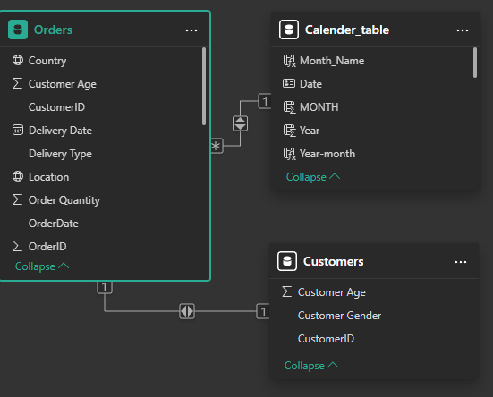

- How can we calculate the total revenue generated by all the sales?

Total revenue of all the delivered Products is
Total_revenue_delivered = CALCULATE(SUM(Orders[SalePrice]),Orders[Status]="Delivered")

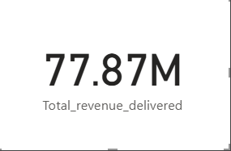

- What is the total number of unique customers who made purchases each year? Is there any increase in the number over the years?

Unique customers = Calculate(DISTINCTCOUNT(Customers[CustomerID]))

There were on average 17.5k customers till 2019 however there was a spike in the number of unique customers from 2019-2020 of 25.2k customers.
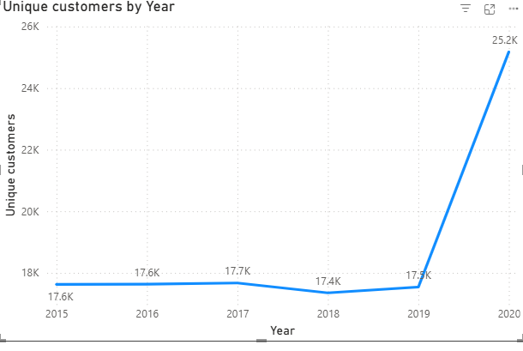

- How can we determine the total number of unique products available in the company?

total count of products = DISTINCTCOUNT(Orders[Product])
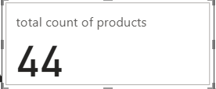

- What is the average number of days it takes for products to be delivered, get the metric for only the delivered orders.

average_no_of_daays = ROUNDUP(CALCULATE(AVERAGEX(Orders,DATEDIFF(Orders[OrderDate],Orders[Delivery Date],DAY)),Orders[Status]="Delivered"),0)

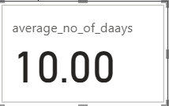

- Which products, categories, and subcategories are the most popular?
- Phones and Tablets are the most popular product Categories according to average ratings and total revenue generated.
- Within Phones and Tablets ,the subcategory mobile phones are most popular with 2.7589 in avg. rating and 15.3 M in total revenue with tablets catching up.
- Samsung Galaxy A02 - 64GB HDD - 3GB RAM Smartphone – Black , with the avg rating of 2.6 is still bringing more revenue (59,49,751 Rs) than the slightly higher rated product- Infinix Smart HD X612 (2021) - 32GB HDD - 2GB RAM – Black
- Perhaps the rating of Samsung galaxy is lesser due to more people rating it as compared to other products as it is being sold more.
- Therefore the most popular product is “Samsung Galaxy A02 - 64GB HDD - 3GB RAM Smartphone – Black”.

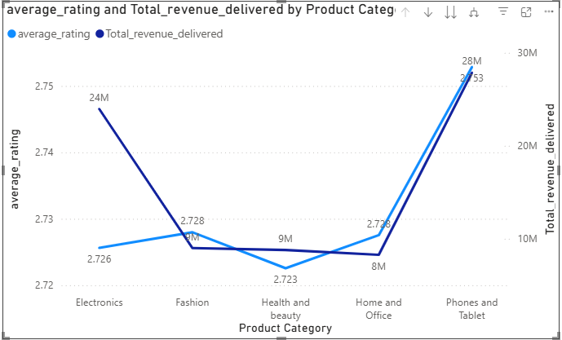

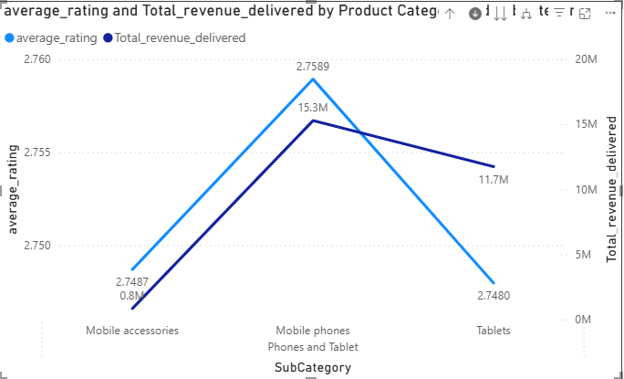

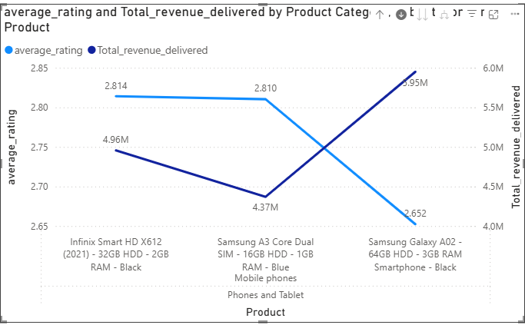

- Which products have seen an increase or decrease in sales over the year?

The analysis of YoY revenue trends shows that products such as Short Sleeve Polo Shirt (Fashion), Heat Resistant Glass Storage Bowl (Home & Office), and Muscle Stimulators (Health & Beauty) are experiencing consistent growth, with YoY increases of 12–15%. On the other hand, high-value electronics like the 6030 3.1 Bluetooth Home Theatre and Canon EOS DSLR Cameras have shown declining sales in recent years, suggesting reduced demand or increased competition.
- Growth is concentrated in Fashion, Home & Office, and Health & Beauty categories.
- Declines are seen in premium electronics and large household items.
- The company should invest in marketing and expanding the fast-growing categories, while reassessing strategies for underperforming products, such as product upgrades, targeted promotions, or bundle deals.

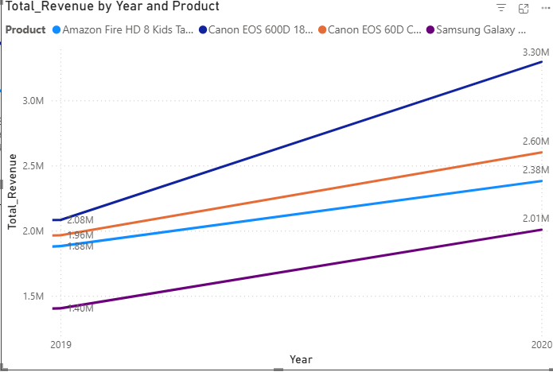
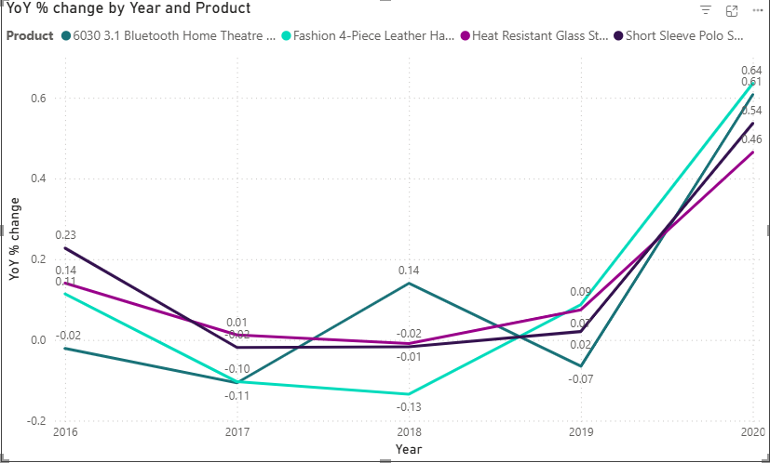
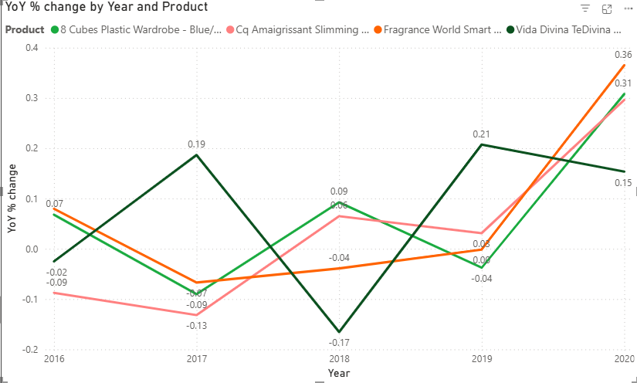
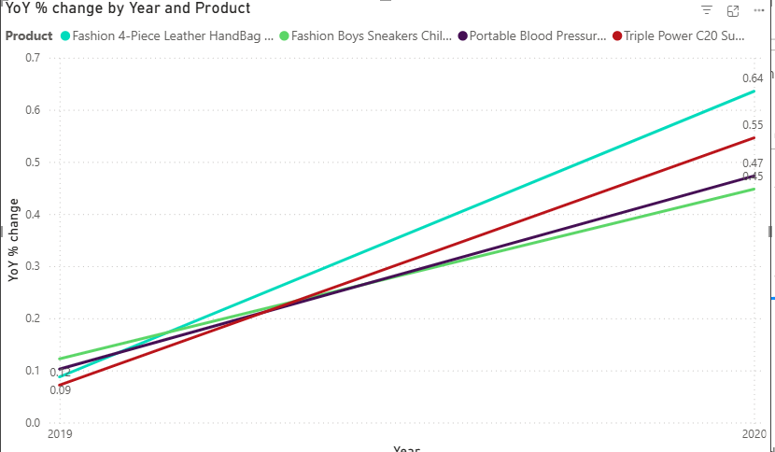
- While modeling the data relationships, what will be the type of relationship between the customer ID of Orders and customer tables?

The relationship between Orders table and Customer tables is One to One .

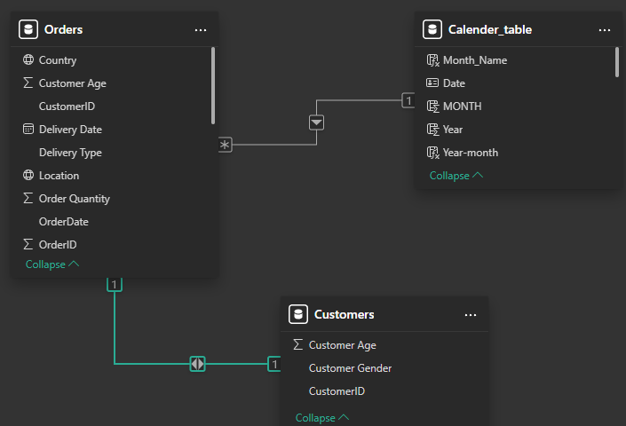

- How have you handled the null values in the data?

- Removed ‘null’ or empty cells from all the columns
- In Reasons column in Orders table , replaced empty cells with “Not Returned”
- Gave appropriate data types to all the columns

- Were there any data format issues in the data, and if there were/are how you would handle them?

Yes, some data format issues did exist:
- Order Quantity stored as decimal instead of integer.
- Shipping Fee as integer needed conversion to whole number.
.
Handling:
- Convert numeric columns to correct data types (Order Quantity → Whole Number, Shipping Fee → whole number).
- Validated date fields to ensure they are in proper Date/Time format.

- When we add a column in Power Query what’s the code that comes in M language in the formula bar? What do you know about M-query?

Ex. = Table.NestedJoin(#"Removed Columns", {"CustomerID"}, Customers, {"CustomerID"}, "Customers", JoinKind.LeftOuter)
M-query (Power Query Formula Language) is the functional language used in Power Query for data shaping and transformation. It records every step of our data preparation (such as changing data types, adding/removing columns, filtering rows) as a code at the back end, which helps power bi to understand our steps in its own machine language . it can also be edited or automated by Advanced Editor.

- Identify the top 5 most valuable customers using a composite score that combines three key metrics: (SQL)
  - Total Revenue (50% weight): The total amount of money spent by the customer.
  - Order Frequency (30% weight): The number of orders placed by the customer, indicating their loyalty and engagement.
  - Average Order Value (20% weight): The average value of each order placed by the customer, reflecting the typical transaction size.

with total_revenue as (

select distinct customer_id , sum(sale_price) as total_revenue
from orders
where status = 'Delivered'
group by customer_id
order by sum(sale_price) desc,customer_id
),

number_of_orders_placed as (
select distinct customer_id , count(distinct order_id) as total_no_of_orders_placed
from orders
group by customer_id
order by total_no_of_orders_placed desc
),

avg_order_value as (

select distinct customer_id , (sum(sale_price) / count(distinct order_id)) as avg_order_value
from orders
group by customer_id
order by avg_order_value desc,customer_id
)

select distinct tr.customer_id,(total_revenue*0.5 + total_no_of_orders_placed*0.3 + avg_order_value*0.2) as weighted_score
from total_revenue tr
join number_of_orders_placed nop on tr.customer_id=nop.customer_id
join avg_order_value aov on tr.customer_id= aov.customer_id
group by tr.customer_id
order by weighted_score desc
limit 5

- Calculate the month-over-month growth rate in total revenue across the entire dataset. (SQL)

with monthly_revenue as (

select date_format(order_date,'%y-%m') as month , round(sum(sale_price),2) as total_revenue
from orders
group by date_format(order_date,'%y-%m')
order by month
)

select month,total_revenue, lag(total_revenue) over(order by month) as previous_month_revenue ,
Round((total_revenue - lag(total_revenue) over(order by month))*100/lag(total_revenue) over(order by month),2) as mom_growth_rate
from monthly_revenue;

- Calculate the rolling 3-month average revenue for each product category. (SQL)

with monthly_revenue as (

select date_format(order_date,'%Y-%m') as month ,product_category, round(sum(sale_price),2) as total_revenue
from orders
group by date_format(order_date,'%Y-%m'),product_category
order by month
)
select product_category,month, total_revenue ,
round(avg(total_revenue) over(partition by product_category order by month
rows between 2 preceding and current row),2) as rolling_3_month_avg
from monthly_revenue
order by product_category,month

- Update the orders table to apply a 15% discount on the `Sale Price` for orders placed by customers who have made at least 10 orders. (SQL)
- Calculate the average number of days between consecutive orders for customers who have placed at least five orders. (SQL)
Max orders a customer made = 1
Therefore no action could be taken.

- Identify customers who have generated revenue that is more than 30% higher than the average revenue per customer. (SQL)

select customer_id , sum(sale_price) as total_revenue
from orders
where Status = 'Delivered'
group by customer_id
having sum(sale_price) > 1.3*(select Round(avg(total_revenue),2) as avg_revenue
from orders
where status = 'Delivered')
order by total_revenue desc,customer_id

- Determine the top 3 product categories that have shown the highest increase in sales over the past year compared to the previous year. (SQL)

with yearly_revenue as (

select product_category,year(order_date) as year , round(sum(sale_price),2) as total_revenue
from orders
where status = 'Delivered'
group by year(order_date),product_category

),
yearly_increase as (

select product_category,year, total_revenue,
lag(total_revenue) over(partition by product_category order by year ) as previous_year_revenue,
round( (total_revenue - lag(total_revenue) over(partition by product_category order by year )),2) as increase_in_sales
from yearly_revenue
)
select product_category,year, total_revenue,previous_year_revenue,increase_in_sales
from yearly_increase
where previous_year_revenue is not null
order by increase_in_sales desc
limit 3

